**WEEK 4:**

Write nested queries for answering the following queries that retrieve data from university database:

1. Find the total number of (distinct) students who have taken course sections taught by the instructor with ID 10101

select count(distinct(t.id)) as "Total Students" from takes t, teaches th where th.id = 10101 and t.course_id = th.course_id and t.sec_id = th.sec_id;

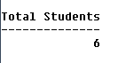

2. Find the names of all instructors whose salary is greater than at least one instructor in the Biology department.

select distinct(name) from instructor where salary > some(select salary from instructor where dept_name like 'Biology');

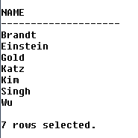

3. Find the department that has the highest average salary.

select dept_name, avg(salary) as "Average Salary" from instructor group by dept_name HAVING avg(salary) >= all(select avg(salary) from instructor group by dept_name);

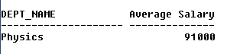

4. Find all the courses taught in the both the Fall 2009 and Spring 2010 semesters.

select distinct(course_id) from teaches where semester = 'Fall' and year = 2009 and course_id in(select distinct(course_id) from teaches where semester = 'Spring' and year = 2010);

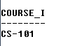

5. Find all the courses taught in the Fall 2009 semester but not in the Spring 2010 semester.

select distinct(course_id) from teaches where semester = 'Fall' and year = 2009 and course_id not in(select distinct(course_id) from teaches where semester = 'Spring' and year = 2010);

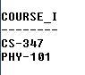

6. Find all courses taught in both the Fall 2009 semester and in the Spring 2010 semester. (Write correlated nested Query)

select course_id from teaches t1 where semester = 'Fall' and year = 2009 and exists(select course_id from teaches t2 where semester = 'Spring' and year = 2010 and t1.course_id = t2.course_id);

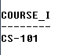

7. Find all students who have taken all courses offered in the Biology department. (Write Correlated nested Query)

select distinct(s.id) from student s where not exists((select course_id from course where dept_name like 'Biology') minus (select t.course_id from takes t where t.id = s.id));



8. Find all courses that were offered at most once in 2009.

select distinct(course_id) from takes where year = 2009 group by course_id having count(course_id) <= 1;

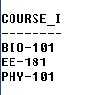

9. Find all courses that were offered at least twice in 2009.

select distinct(course_id) from takes where year = 2009 group by course_id having count(course_id) >= 2;

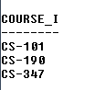

10. Find the average instructors salaries of those departments where the average salary is greater than $42000.

select dept_name, avg(salary) as "Average Salary" from instructor group by dept_name having avg(salary) >= 42000;

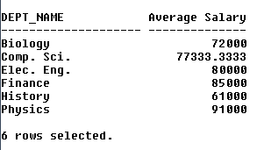

11. Find the department with the maximum budget.

select dept_name from department where budget = (select max(budget) from department);



12. Find the names of instructors who have not taught any course.

select i.id from instructor i where not exists(select t.id from teaches t where t.id = i.id);

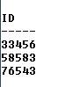

13. Find the IDs and names of all students who have not taken any course offering before Spring 2009.

14. Find the lowest, across all departments, of the per-department maximum salary computed.

15. Display the IDs and names of the instructors who have taught all Comp. Sci. courses.